1. Business process identification

This is a One Cloud data structure that I’d like to propose for my previous company who were struggling with the defining a better data model for the cloud Service offerings and the tenant structure defined currently for their One Cloud which is a SaaS service offering platform.

Basically One Cloud is a platform that offers multiple SaaS services specifically- Network , Database , Computing Capabilities. There are various services defined under each category accordingly and used by the tenants who are charged based on their utilization of resource for their time.

1. Access of data

Data is accessible through the One Cloud portal according to the user that logs in. there are three categories of users namely – Service Provider, Service user/Customer and the Admin.

According to their specific privileges they are assigned their access rights to view the portal.

1. Dimensional model design

**Date   
(Dimension Table)**  
  
Date_id  
Year  
Month  
Time_of_use  
Date  
  
Offering   
Unit cost  
Configuration  
Service description

**Location   
(Dimension Table)**  
  
Location ID  
Service offering   
DC Location   
Usage_unit  
Price  
  
  
Offering   
Unit cost  
Configuration  
Service description

**Service Usage   
(Fact Table)**

Tenant ID  
Service ID  
Date_ID  
Usage_unit  
Price  
Total Cost

**Offering  
(Dimension Table)**  
  
Variant name  
ID  
Unit cost  
Service type

**Tenant  
(Dimension Table)**  
  
Tenant name  
Tenant ID  
Type  
Tenant usage Infor  
Taenant branch  
Tenant service subscription

tenant userage

**Service   
(Dimension Table)**  
  
Name  
ID  
Type  
Offering_id   
Unit cost  
Configuration  
Service description

Define Fact Table definitions-

Here there are one fact table –

* One is having sales which consist of the unit usage by the tenant and unit pricing from the offerings table of the service. This will be used to calculate the final Charges applied per tenant for their specific service usage. There are all numeric attributes of capturing the details of which service has been used and how long it has been used by the tenant. This gives brief information of the details for Tenant ID, Sales of the Service Offering and unit of usage.
* All are numerical Attribute of, - hours of usage. Units of usage., Final price that would be borne by the tenant

Dimensions:

* The dimension tables for Service Usage Fact Table are Tenant, Service Offering, Usage, Service type, Service name, hours of usage. The dimension tables for service usage fact table are Service user, provider, admin, service, usage unit and hours of usage.
* Tables of Service Offerings, usage, pricing and Tenant are the conformed dimensions since they are commonly used for fact tables.
* Following is an example of how conformed dimensions are used for the schema-

Also, the time is an important dimension which is used to count the number of units and hours of usage of any service. Since the resources are blocked, they will be charging for the respective service usage. In future we might track more lower level of usage based on per minute, so more time attributes will be required to work upon to expand the existing view. We can add more physical tables based on respective service usage and definitions. Hence it is expandable. Only the dimensions for Service offering, service and Time with price will remain as a source to charge the tenant user.

* If we see now, we have multiple tenants for a single service. This is required as part of connectivity to represent hierarchy between the fact table for service usage and the tenant description. The navigation contains one record for each pathway from parent service to each tenant user. So relation between Fact and bridge table and between tenant and bridge are many to one.

* Here we can see, there could be multiple tenants for a single service. And For the navigation bridge table between fact table and the dimension table for a Tenant can be connected based on the multiple tenant ID s and the service that serves those tenant, it will be many to one. The other way to have a fact table connected from multiple services to a single tenant hence it can also be modified as –
* Diagram

  Description automatically generated

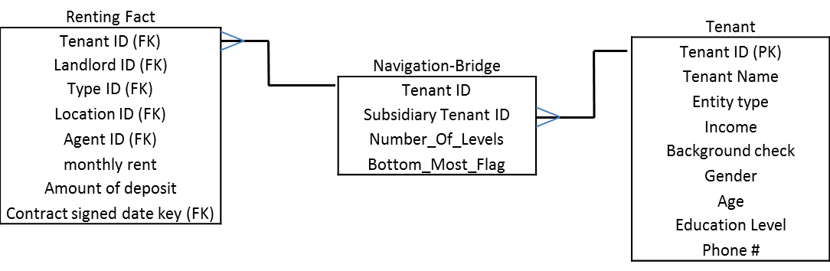

* I was thinking to inculcate the location attribute for a service in a DC linked to its respective service offering, but it would create a repetition of the same value across all the usage. Hence on changing the location attribute with Time dimension to an independent one will solve this issue instead of building a huge redundant value columns hence also helps in normalization of the tables.
* Every dimension has a hierarchy, like already mentioned before, the Tenant can be Admin tenant, Service Provider or a User. Also, the services can be categorized further to Network, Computing or Databases on their respective types. This helps in maintaining a proper dimension structure that helps to further categories of specific values.

Attributes and keys:

* The Service Usage fact table has a composite primary key. For example, Service ID and Tenant ID act as the composite primary key. And these primary keys are all surrogate key generated by the system.
* Primary key for all conformed dimensions is surrogate key as well since this is required.
* For the Time and Location Dimenstion the use of actual Date (YYMMDD) can be considered as semi intelligent key and for the time dimensions as a prefix in the surrogate key. For example, Every service hourly usage will be represented with their respective timestamp that works from START_TIME and ends with END_TIME with format as ‘YYYY-MM-DD HH24:MI:SS’.
* Also we have foreign keys in the fact tables which are the primary key from the dimensions. Since these dimensions are conformed dimensions, surrogate key is also required.
* Note that there are several attributes that are conformed facts in Service usage fact table. For example, Location, Service Offering,unit of usage are few of the conformed facts.

Grain:

* The fundamental grain is the individual transaction. Therefore, the fact tables are measured at an instantaneous point in time, not over a time span. For example, the Service Usage fact table For every tenant service usage we define only a single row of data entry with its respective service usage.
* The grain of time table with calendar information is on date only. However in the future if there is business need to have grain of per second unit usage per tenant as accounted by timestamp in the fact table, we can create an attribute that will have a lower level dimension for the Hours of Usage dimension for the service usage fact table.